"Why Travel Exuma?"
66
rate or flag this page
By lanealanea

Where you go, nobody knows especially this place called Exuma.
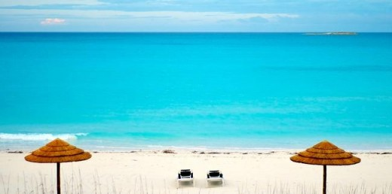

See all 79 photos

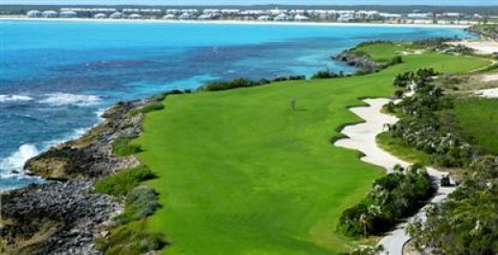

Little Note To The Reader...
I know, I know, I know its not good to publish this draft of my Exuma trip. I have been trying for months to finish it but I just have to much to say about it. I promise that I will write all the rest I want you to know about it and see what else we did, including a little about how Johnny Depp who played in the pirates of the Caribbean lives across the water where we were, you know...
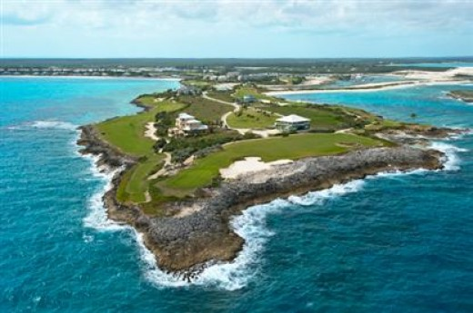
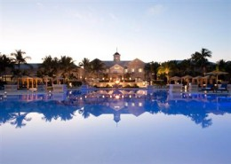
- The Exumas - The Out Islands | The Bahamas
The ExumasEverything here is precious, especially the aquamarine and sapphire-colored water.The Exumas are an archipelago of 365 cays and islands, beginning just 35 miles southeast of Nassau, an exotic collection of tiny jewels set in the most beauti

"The Exumas", Everything here is precious, especially the aquamarine and sapphire-colored water.
The Exumas are an archipelago of 365 cays and islands, beginning just 35 miles southeast of Nassau, an exotic collection of tiny jewels set in the most beautiful aquamarine and sapphire water you’ve ever imagined. Great Exuma Island, together with the Exuma Cays offer an amazing variety of vacation possibilities, from resorts and hotels with luxury amenities to basic fishing lodges. Hidden coves, bays, and harbours throughout are magnets for yachts and sport fishermen.
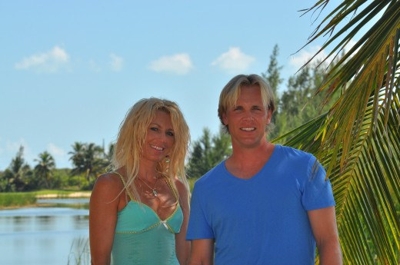

"Well, there was a little bit of wind." And, some other fun stuff.
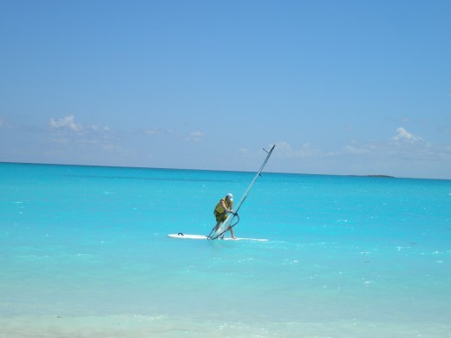
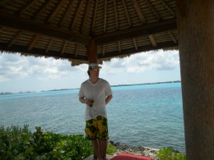
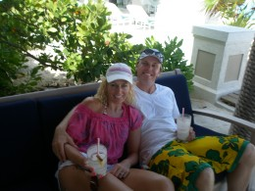

Extraordinary Exotic Exuma
And, it started like this,
Welcome To Sandals Emerald Bay, your home away from home. We are delighted that you are occupying one of our suites, which provides you with your Butlers, who are at your service to ensure that all your needs are met and expectations exceeded.
Your Butlers whom were specially trained by the Guild of Professional English Butlers to the highest standards, thus providing you with a vacation experience second to none, where your total satisfaction is their goal.
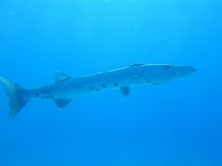
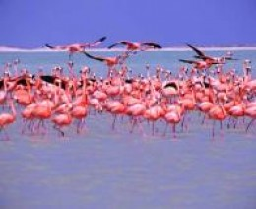
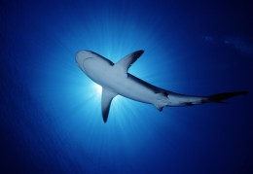
Advertising Space - After your Hub is published advertisements may be placed in this space. Please note, it can take some time after you publish for the ads to match the content of your Hub.

"Conversation with the shuttle driver"
From our resort stay at Sandals Royal Bohemian for days 1, 2, 3 to (Nassau, New Providence, Bahamas, West Indies) airport we had the chance to talk about where we were continuing on to a place called Exuma. Exuma is one of the out islands of the Bahamas.
There was a hurricane approaching near where we would stay in Exuma. I asked him about the the people on the island and what they would do in the case of a hurricane and how we would know if we were going to be safe. I asked if there were any signs or signals that we could look out for so that we could get to safety.
This is what he said...
When the waves are present in the Caribbean, a hurricane is occurring. Red flag warnings are in the ocean which means no swimming. When the trees are calm and still, the hurricane is near. He also said that we should not worry because the hurricane had just turned and will be gone by the end of the day.
He mentioned that Exuma is very unique because each island next to Exuma get prettier and prettier as you reach each one. One island in particular named Iguana is utmost beautiful. Sharks and barracudas are there. I asked for some tips about what could attract them to us and he said that they are attracted to shiny jewelry and that if you wear it, you are giving the message to them to come and get you. Never wear shiny jewelry into the ocean period. Sharks in the Bahamas swim and hunt for food at night.

"In the middle of no where, we are somewhere out here"
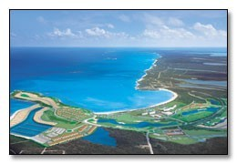

" About The Butlers, I Quote,"
The sun feels so good on my face that its nearly impossible to protect it by wearing a hat all the time its just nuts really it sort of changes you here well thats just me i guess i am still trying to get settled here its so overwhelming the butler services here see you cannot "not" have a butler everyone has one and its harder to get something without a butler so its almost like you have to ask for everything from him which makes you feel like you keep asking for stuff even if its little. for example, i wanted to ask for a cappuccino, a shrimp salad and my husband wanted a hot dog right? So, that took the butler a long time like an hour which we both fell asleep in the meantime and went straight to soccer before we missed the game hee, came back and there was our food so he said he apologized but our requests were in three different places he had to walk far to get them from there ha so of course had we known we would of had a pool butler get a pizza or nachos and a tea and coffee something like that and thats what I mean about still trying to get use to it. cant say how we will get along at home without anyone helping us do everything hee. we probably use ours on a scale of one comparing to others we see but so cool they can do special things for you but still getting it down. music just went on on the resort and i can see those famous house movie stars think its johnny depp and country singer mccarthy i may be so wrong but something like that from my patio outside here some kenny G is playing softly right now and i can see the water waving slowly in ocean. have to tell you how we get the golden nachos to the pool tablle taihitian style later husband hilarious invention on rafts so funny indeed its such a different world here that even if they try to make it like a four seasons in los angeles it has a way of taking your mind body and spirit away from it all and then gives you that sort of thing

"And So, I Say.."
I think ill skip photos till i get back. clay court tennis played 2 hours only ones around stadium seating courts har-true super cool totally different game. soccer on beach my husband was the goalie of the other team and i got a couple bruises on my shins from sliding in the sand. was so fun but the ball was the same color as the sand and so it was so hard to finally get the ball, dribble it and push it ahead then you go to kick it and you look down and hard to see it quickly to score barefoot i had several almost goals ha! goalie was just too good you know. outside with cinaomin "french" "French toast" coffee, grapefruit and some more perfect designed fruit shaped beautifully mmm good yes, ate all that still working on the rest of y fruit was raining when started to write this now so bright i cant see the screen of this ipad ha so because i am outside on patio. swam for 4 hours yesterday and a half hour at night getting several ideas for my new diet book and travel book i am very excited to do something on Exuma its way too out there of an island not too still trying to get an idea on how to explain the difference here then from bahamas main part its just so spectacular, going inside. its raining beside me sprinkling i
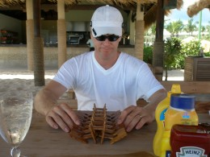
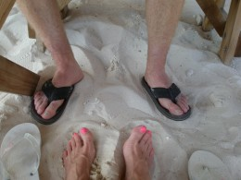
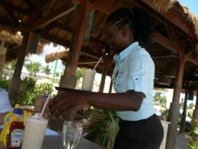
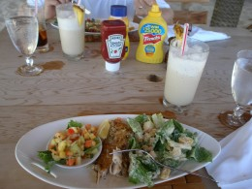

"Barefoot By The Sea"
Our Favorite Restaurant, I believe that we went here everyday. My favorite dish I had everyday there was the mahi mahi salad. I think, I think I forgot actually, yeah that is right. Ross had the Chocolate Monkey to drink and I had a BBC and an Iced Tea. Anyway, it was so funny because they played this song "Who let the Dogs out." And, here is a cat right there in the sand while we are waiting for our food, Ross kept saying who who and I will tell you why its funny, not just because of that. Okay, so we are on the tennis courts playing one morning and the place is so gigantic of a resort that its like the resort is its own island on its own. Anyway and so, we are playing this intense game of tennis in the warmest weather possible, clay courts and all, here are these wild dogs running behind the ungated courts right, I say to Ross, "How cute honey, look there are dogs, maybe they can help pick up the balls for us." He was like what? Yah right, those are wild dogs and what are they doing here? He had experience with wild dogs and what they could do if they wanted to and here is me too comfortable with my memories of my playful black lab I use to have. Say no more, we had to report it and it freaked him out. I donno, hard for me because I havent seen a wild dog attack much. So, back to the restaurant "Barefoot by the Sea," We heard that song in the afternoon there as we were waiting for our lunch. "Who? Who, let the dogs out and he said Who Who?"
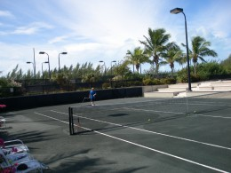
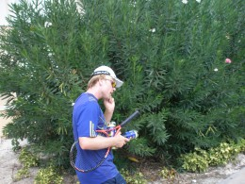
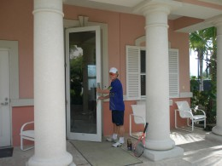

Next to this area, was a soccer tournament. We Played
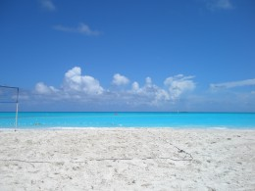

The Contract
Well, it started out that we were going to travel and had our reservations to do a split trip in Saint Lucia at the St Regency La Toc and The Grande St Lucian, that is before we were approached with a great offer to teach tennis at the resort at the all inclusive and all butler suite in Exuma.
They said that the new Womens Pro Golf series show was going to be filming there and they were trying to promote it so we were able to stay and not have to pay.

Well, They had Two Tennis Pros and One Work Day
They had two tennis pros and they only needed one of us. We all together chose Ross
I didnt have to do a thing and my husband had to work one hour, it was rough.
But, as being such a hard worker and a dedicated pro, we stood by waiting for the call for a private tennis lesson but heck, who wants a tennis lesson when they are at Exuma.

Beach Soccer and...
When you do need a butler, Well, you do not have one.
It was hilarious. If we wanted some water, you need to call your butler. If you would like some nachos, you need to call your butler right? Might sound funny but no matter where you went, you need to call your butler. So, we started doing so. We had anything we wanted if we called the butler. You turn to your left, there is a butler. You turn to the right, there is a butler. But, when the resort decided to have a soccer tournament on the beach and many people participated, do you think that anyone could find a butler? You would think that there might just be a butler where needed the most for some water. Or how about the photographers to take a photo of the event in case you want to add one of the memories, nope not a photographer in sight. It was hilarious. Nobody scoring goals could believe it. At each end of the pool where there is a raft floating there is a butler around to catch your order. It was just interesting to all.

While waiting for me to get ready,
Ross was so bored, he decided to do some push ups before our photo shoot. Heh, you know how it is getting ready in a formal outfit in the beach bathroom right?
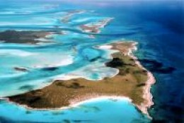

The Exumas
Stretched over 120 miles of sea, this collection of cays and islands is ideal for those eager to explore hidden bays, untouched beaches and quiet coves. With 365 islands to visit, an island-a-day regiment is just the perfect regiment for a stress-free year. This chain of islands is ideal for those with access to a yacht. The turquoise waters make for amazing diving as well.

One Acre Zero-Entry Pool
Designed to impress, this One-acre pool sits at the heart of the resort. At night this pool takes on a romantic character with its fire-pit, and a saxophonist playing from his evening spot in the Sunset Tower.
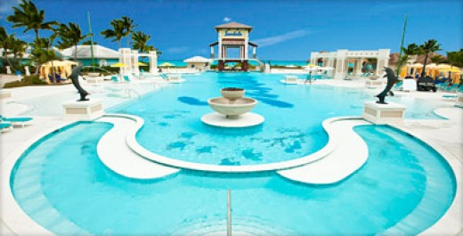
Source: "I Say No More"

Your Own Private Exotic Escape
Scattered like pearls across the turquoise sea, the 365 islands of the Exumas have a special magic found nowhere else and are most hypnotic and alluring of all the Out Islands.
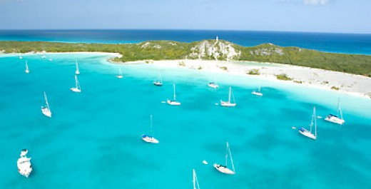
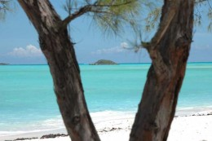

The Islands of the Bahamas
Nassau/Paradise Island You’ll find our capital city, Nassau on New Providence Island, neighbor to Paradise Island. Offering a distinct blend of international glamour and tropical ease, this unique island pair gives you the freedom to do everything or nothing at all. So, kick back. Enjoy.
Grand Bahama Island You can look forward to a memorable mix of historic charm, modern attractions, and ecological wonders on your visit to Grand Bahama Island. There’s truly something for everyone. The warm welcome you’ll receive is just extra insurance that you’ll return again and again.
The Out Islands These hidden gems come in the form of small remote villages and a simple way of life. Here you’ll find some of the world’s most stunning beaches, dive sites, and fishing sites – a welcome surprise if you’re looking for that perfect mix of relaxation and adventure.
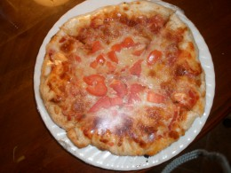
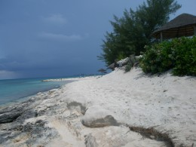

Pizzeria, yes and looks aren't everything.
It tastes great! Well, you can always count on pizza. Great pizzeria there, perfect before workouts ha! It might sound crazy but see when you are there at a resort working out all day, from the pool, to the gym to the ocean to the pool then to the tennis courts. Not so bad to include a mini pizza every afternoon which I think we did.

Off shore private Island,
There was thunder and then there was the lightning. Next, we left to the other side. The sound was incredibile and a little scary at that. Ever been on a private island and experienced lightning? Well, it is real when you are there.

And, Just Like He Said, He Did.
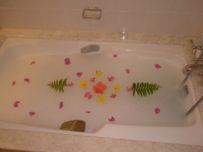
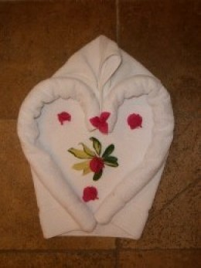
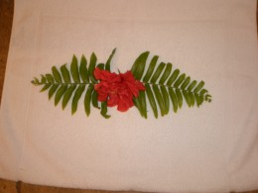

"About A Butler"
This is so funny to us this story here. We all had to have a butler and who would want to complain about that. This at the time was an "All Inclusive and all butler suites resort." Therefore we got a butler. We were first sort of shy to call the butler as we are not use to being waited on hand and foot. We thought that if we didnt ask for much that if we did request something then voila right? Hee, not so sure about that. So, we watched here and there as people would requests things like a special bath with flowers something different something unique to be prepared for an evening. So, I called "De Angelo, the Butler," He answered like so. We said Hello De Angelo, wondering if we could maybe request for a bath to be made for us anytime later. He said sure, we said great and no bath happened right? So, we laughed about it and talked about how funny that it was we never even used the butler for anything yet. Well, so just out of curiosity, thought maybe he forgot or gave it to the wrong room right? I called again to ask again, do you think that you could please make a bath for us and he said, why don't you let me surprise you. And, I said okay that sounds good, I was sort of embarrassed but guess what, we did not see any bath. The next day we had a different butler and we asked in the afternoon just to see if it was for real, we were in disbelief and now really wondered about what to think about it. Well, came back from tennis and voila a bath. It was awesome. Do you know that, we never did find out and even when we saw him, tipped him, he just never said a word. It was such a story to tell hee
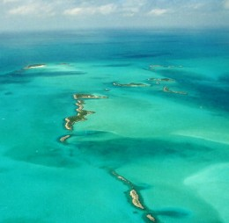
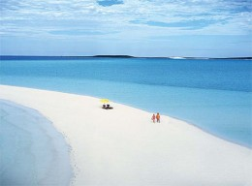
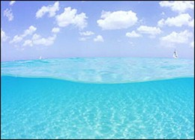

The Exuma Cays
The Exumas are made up of 365 islands and cays strung out across more than 120 miles of ocean. The Exumas are home to some of the most dazzlingly beautiful waters in the world.
From the air, these cays look like jewelled stepping stones surrounded by a shimmering emerald sea, making this chain one of the prettiest in The Bahamas. The bright white sand of the deserted beaches contrasts strikingly with the deep aquamarine and jade hues of the water. Most of Exuma's 3,600 residents live on Great Exuma or Little Exuma, the two largest islands which are connected by a short bridge. These friendly and outgoing people are genuinely happy to welcome holidaymakers. Most Exumians make their living by fishing or farming, with the main crops being onions, tomatoes, pigeon peas, guavas, papayas and mangoes. Visitors will also find wild cotton growing on Exuma - a testament to the importance of this plant in the island's history.
The Many Cays of the Exumas
are considered by many to be the most beautiful islands in the Bahamas, a difficult title to achieve for certain. Once you arrive, your breath will be taken away by the rolling hills, deep blue waters, and fine white-sand beaches. Stretching over 90 miles, these remote islands are still virgin territory waiting to be explored. The abundant coral reefs are perfect for divers and underwater photographers, protected from strong currents to give high visibility in all weather conditions. This world-class location is also a mecca for diving enthusiasts, who come down to the Exuma Cays for an underwater adventure unique on planet Earth.
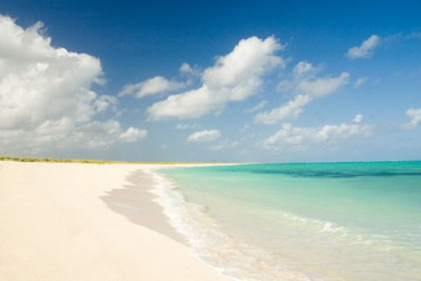
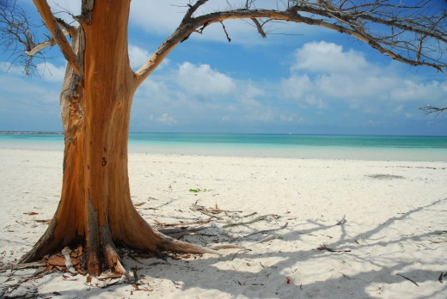
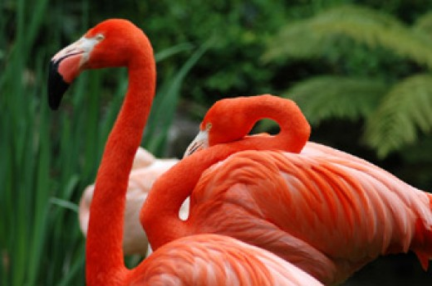
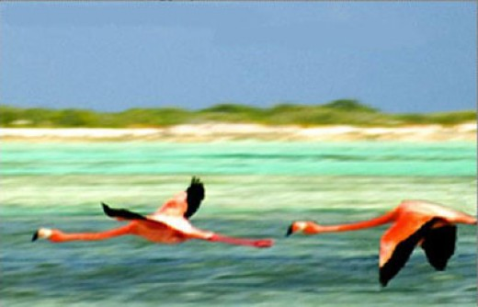
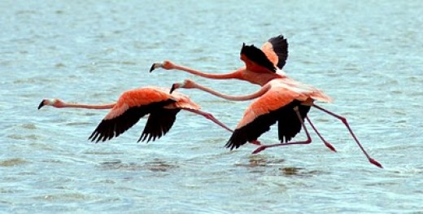
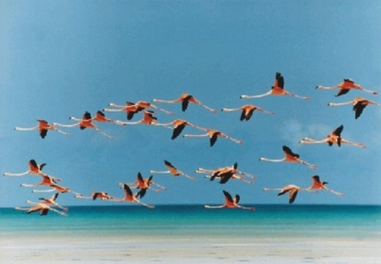

Airport Nassau Bahamas (NAS) This is almost the size of the whole airport, its just not that big
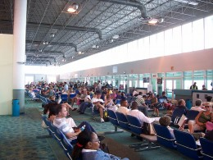

Nassau International Airport Ground Transportation
Nassau Airport has no public transport infrastructure. Taxis and hire cars remain the only options for travel around New Providence or to the nearby islands via ferry.
- Nassau International Airport
Nassau International Airport - Arrivals, departures, weather, delays, transportation, maps

Georgetown Airport Exuma Bahamas Below
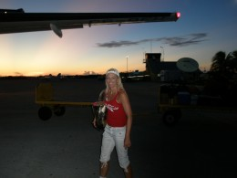
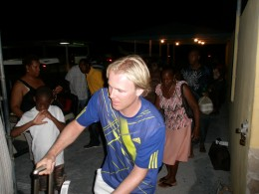
- George Town Airport, Exuma International Airport (GGT) George Town, Bahamas
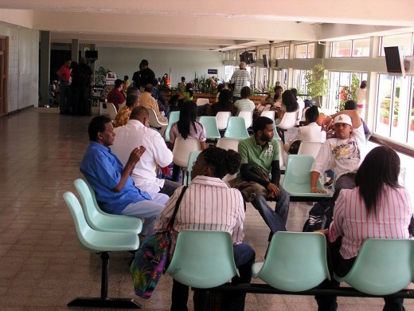
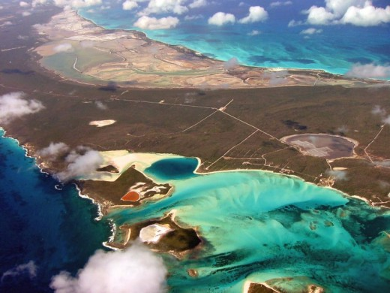
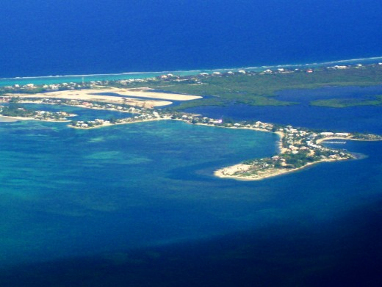
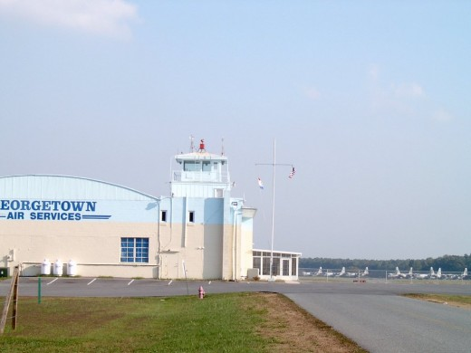
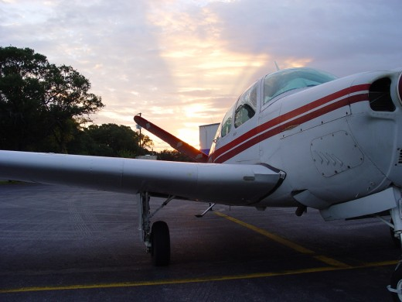
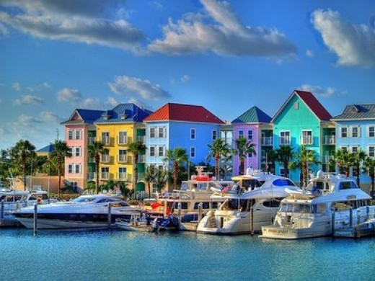
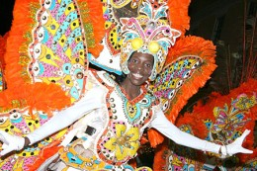
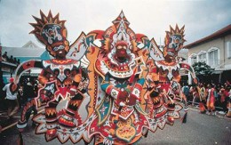

Junkanoo
Junkanoo is a Bahamian custom celebrated in the early hours of Christmas morning. The name is said to be a corruption of “John Canoe” who was a prince and slave trader based in West Africa.
Slaves arrived in The Bahamas with their white owners to work the cotton plantations. they had three days holiday each year and the slaves celebrated by producing elaborate costumes and dancing to their native music. Over the centuries this developed into street processions and competition between the settlements for prizes for the best presentation. This tradition has continued with keen rivally and also as an attraction for the tourists
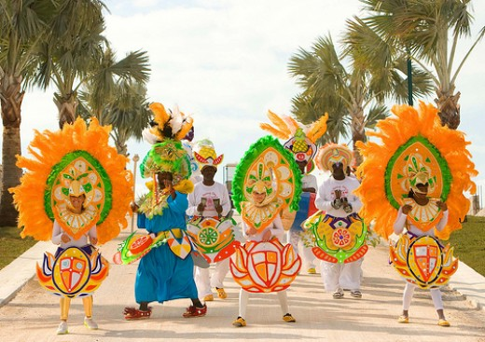

Lion Fish 2
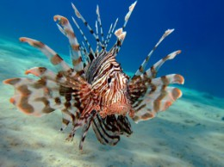

Lion Fish 2
From Science Today: The invasion of the predatory Lionfish in the Caribbean region poses yet another threat to coral reef ecosystems. A new study has found that within a short period after the entry of lionfish into an area, the survival of other reef fish is slashed by about 80 percent.
Aside from the rapid and immediate mortality of marine life, the loss of herbivorous fish also sets the stage for seaweeds to potentially overwhelm the coral reefs and disrupt the delicate ecological balance in which they exist.
“This is a new and voracious predator on these coral reefs and its undergoing a population explosion” “The threats to coral reefs all over the World were already extreme, and they now have to deal with this alien predator. These lionfish eat many other species and they seem to eat constantly” said Mark Hixon, Professor of Zoology.
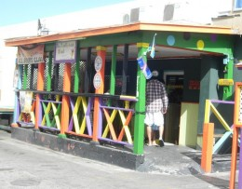
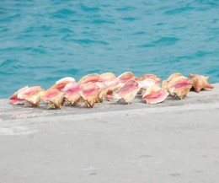
You may be familiar with conch (pronounced "konk") shells. They are basically GIANT snails. The meat of the conch is second in popularity only to the escargot and is very popular in the Bahamas (and the West Indies too).

Dean's Blue Hole, Long Island Blue Hole in the Bahamas named one of the world’s top ten snorkeling spots
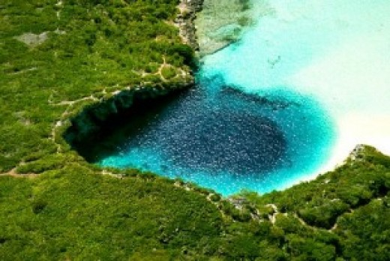
- September 2009 Exuma Properties
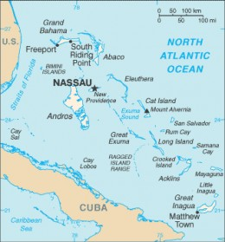

Discover The Islands Of The Bahamas
According to the Bahamas Tourism office the Islands of the Bahamas is unique with their individual character and charm--and there is some truth to this.
Visit the main islands like beautiful Grand Bahama Island (Freeport/Lucaya) and bustling New Providence (Nassau and Paradise Island).
Or, if you really want to get away from the crowds, visit one of the many out islands like Abaco, Andros, Acklins and Crooked Island, Biminis, Berry Islands, Cat Island, Eleuthera, Exumas, Inaguas, Mayaguana, and San Salvador.
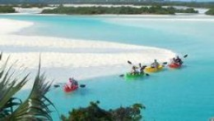
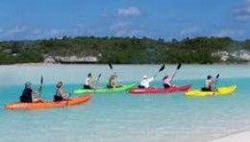

Tours

Kayak In Paradise- Exuma
Become one with your environment in this peaceful, close to nature journey! Following a safety & instructional briefing from one of your friendly, highly knowledgeable guides, you’re ready to claim your kayak and let your dreams take over. Leave the historical “Ferry Bridge” and slowly paddle your way through the shallow waters of the Moriah Marine Park. . Swim at a beach that is ever changing as you drift with the natural gentle current. Finally, kayak back to shore through a meandering maze of mangroves while your guides teach you about the birds and creatures that call this ocean jungle home. Light refreshments provided (water, fruit)
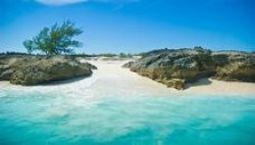

Brigantine Island Adventure Tour Bahamas
- http://www.islandroutes.com/tours/descriptions.cfm?event=ehTours.dspDescription&tid=96&cid=9

Brigantine Island Adventure Tour Facts: Enjoy a fun filled action packed excursion aboard a 35 ft Custom designed PowerCat while you snorkel, beach comb and experience all the beauty of the Exumas in one tour. Your captain and first mate will entertain you with excellent knowledge and first class service as you cruise in and out of over 20 magnificent, little known cays. Experience the feeling of wind in your hair and sand between your toes. Jump into the midst of a reef with hundreds of tropical fish. Wade in crystal clear waters and snap photos you will never forget. Search for shells on a white sand sandbar and immerse yourself in the true serenity of the Bahamian Out Islands.
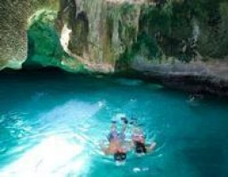
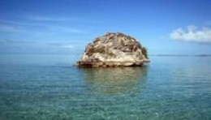

007 Thunderball Tour
Welcome aboard the “Exzooma”, a 35ft Sea Rocket that can travel over extremely shallow water. In intimate groups of no more than 14, you will embark on your journey from the sleepy settlement of Barreterre. From here you will cruise by celebrity homes, see large iguanas in their natural habitat, stop to incredible beaches and enjoy a tiny cay with 4,000 coconut trees. Take snorkeling to a new level with an amazing guided tour in the canyons and caves of the infamous Thunderball Grotto. Play with the "swimming pigs" and jump into azure blue waters while you swim with friendly sharks. Finish the day with the worlds best "home-made rum cake" on a perfect two-mile-long sandbar in the middle of nowhere.
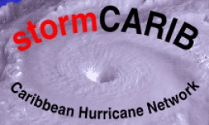
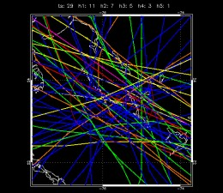
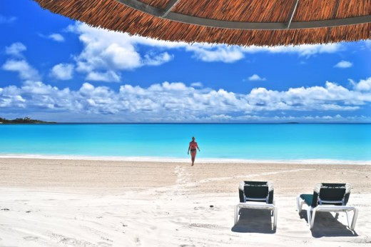

"The Big Jump"
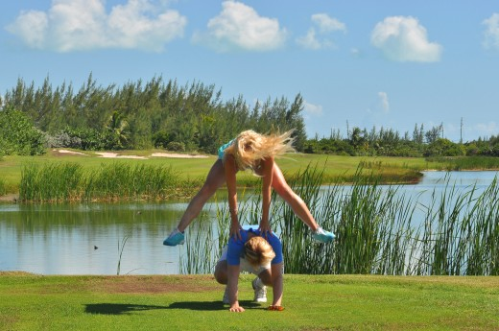

Fun Quiz
view quiz statistics
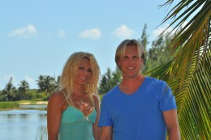
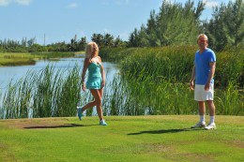
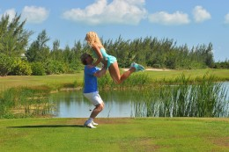

Big Break Sandals Resort
Here at Sandals is where they filmed the womens professional golf tv series, many of you may have heard of it. See videos below.
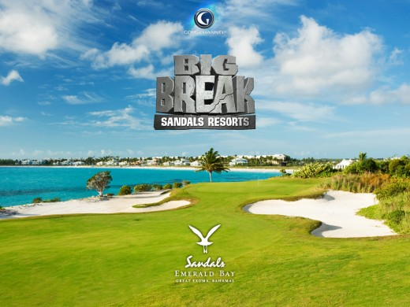

The Big Break Sandals Resort
- http://www.thegolfchannel.com/big-break-sandals-resorts/
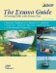 |  | The Exuma Guide 3rd ed.  Amazon Price: $43.75  List Price: $59.95
The Exuma Guide: A Cruising Guide to the Exuma Cays : Approaches, Routes, Anchorages, Dive Sights, Flora, Fauna, History, and Lore of the Exuma Cays
Amazon Price: $156.32
List Price: $44.95
Bahamas Central - Andros to Exumas & Eleuthera Islands (NV.Charts, Reg. 9.2)
Amazon Price: $79.95
Exuma Cays - Warderick Wells to Staniel Cay (NV.Charts, Reg. 9.2.1)
Amazon Price: $14.95
Exuma Tide A Bimini Twist Adventure
Amazon Price: $9.05
List Price: $11.00
Great Exuma! Great Food!: A Bahamian Cookbook
Amazon Price: $12.95
Exuma 1
Amazon Price: $9.40
List Price: $19.98
Great Exuma the Bahamas Mini-map & Reef Creatures Identification Guide - Fish ID
Amazon Price: $5.95
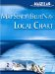 | Magellan MapSend BlueNav Local Chart Great Exuma Island/Long Island Salt/Freshwater Map micrroSD Card  Amazon Price: $149.99

Tour Around Sandals Resort
Advertising Space - After your Hub is published advertisements may be placed in this space. Please note, it can take some time after you publish for the ads to match the content of your Hub.
vote upvote downsharePrintflag
Was this Hub ...?
- Useful (2)
- Funny (1)
- Awesome (2)
- Beautiful (3)
- Interesting

CommentsFollow (2)
sherrylou57 Level 3 Commenter 9 months ago
Thank you for sharing this wonderful hub! Beautiful pictures!!
- Deny
Status: Approved.
ip: 76.238.242.242
BRIAN SLATER Level 1 Commenter 9 months ago
Amazing hub-great photos-love the tomato sauce on the table!
Will you take me next year:)
- Deny
Status: Approved.
ip: 86.181.178.8
Mentalist acer Level 7 Commenter 9 months ago
A diver's paradise,do the Butler's dive,lol?;)
- Deny
Status: Approved.
ip: 74.193.214.132
lanealanea Hub Author 9 months ago
Haa yeah about the ketchup, the table has cut outs to put those in but forgot to place them back.
- Moderate my own comment
Status: Approved.
ip: 70.181.114.12
Jennifer 9 months ago
Oh, wow, that's amazingly beautiful!! I've been to Paradise Island...but now I definitely want to go to Exuma!!
- Deny
Status: Approved.
ip: 68.228.84.228
Tanya 9 months ago
Love the story! Pictures are incredible!!!
Would love to visit one day!
- Deny
Status: Approved.
ip: 68.123.207.173
wendy87 9 months ago
Bahamas seems heaven on earth ....very detailed information about this beautiful place thanks for sharing
- Deny
Status: Approved.
ip: 124.253.136.219
Ruchira Level 6 Commenter 9 months ago
beautiful pix and very informative hub...thanks!
- Deny
Status: Approved.
ip: 75.18.222.233
Pam Carroll 9 months ago
I had never ever heard of Exuma...after reading your Hub and seeing the pics...it is now on my 'Hit List' looks beautiful and sounds like you had a fabulous time.
- Deny
Status: Approved.
ip: 115.128.6.77
lanealanea Hub Author 9 months ago
Thank you, and Pam, don't worry because we hadn't heard of it either until just before we went there. We didn't even know how we were suppose to get there. Now, even you know. Have a great day and bybthe way, when I clicked on your article about distractions by accident, I totally loved it! You should write about that on hub pages and be sure to tell me when you do, it's just awesome, thanks Pam
- Moderate my own comment
Status: Approved.
ip: 70.181.114.12
Ashantina Level 5 Commenter 9 months ago
Bookmarked!
Lanealanea, will I look as glowy and ethereal as you when I get back?? :)
- Deny
Status: Approved.
ip: 82.31.243.114
H P Roychoudhury 9 months ago
It is an excellent hub-excellent in exhibition, picturesque and writing too. People in general like nature, the creation God even though artificiality can create superior display of beauty.
- Deny
Status: Approved.
ip: 117.198.57.104
Jangaplanet Level 4 Commenter 9 months ago
This is a great hub! awesome pictures. Took me awhile to view all the pictures, thanks for sharing this :)
- Deny
Status: Approved.
ip: 70.30.231.38
ChristineVianello Level 3 Commenter 6 months ago
This trip looks like it was amazing! I love the pictures!
- Deny
Status: Approved.
ip: 204.96.18.5
Hunbbel Meer Level 4 Commenter 4 months ago
An extremely serene and soothing place, I reckon. Beautiful pictures too.
It seems, you have spent a lot of time finishing this hub. It deserves more views, best of luck :)
- Deny
Status: Approved.
ip: 182.178.62.214
Robin Cristy 4 months ago
Oh my gosh! I'm going to come visit you!
- Deny
Status: Approved.
ip: 76.178.100.164

